Docker Advance Assignment -2

* Take an existing Dockerfile and optimize it for build speed and image size.

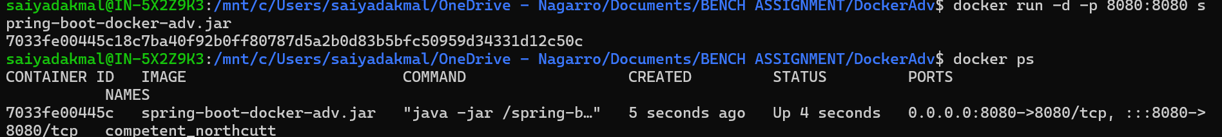



After optimization



**Reduced from 491MB to 428MB**

* PTO
* Set up a custom Docker network and connect multiple containers to it.
* Use Docker commands to inspect and manage the network.

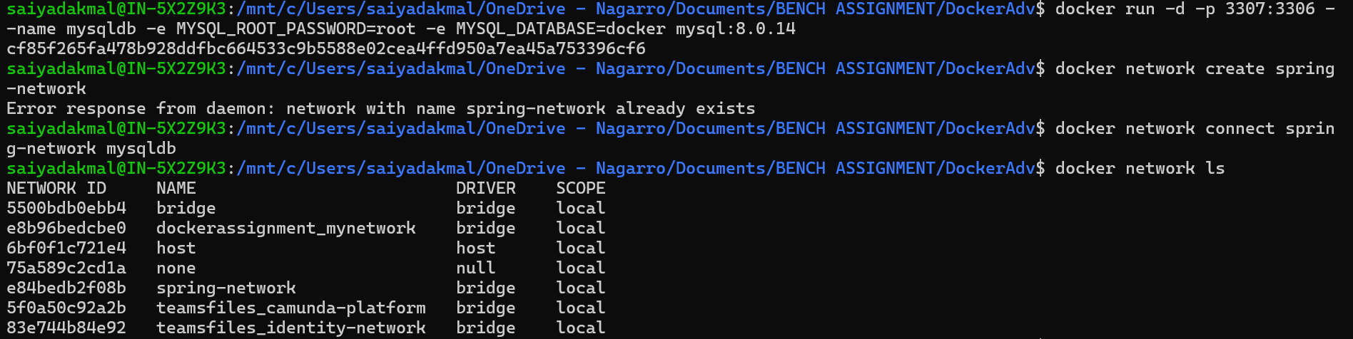

* Create and manage Docker volumes to persist data for your containers.
* Use named volumes and bind mounts and demonstrate how they can be used in a multi-container setup.
* Backup and restore data from Docker volumes.

By using docker volumes Data still persists even after shutting down docker container

* Implement security best practices in your Docker setup, including user permissions, image vulnerability scanning, and secret management.
* Configure Docker to run containers with the least privilege.
* Use tools like Docker Bench for Security to audit your Docker environment.